At first glance OpenPV 2.0 will look a lot like 1.0. However, several features may have moved around to accommodate the expansion of system functionality. Below are some of the UI Changes to help you quick familiarize yourself with the new flow.

Changes to the Project View
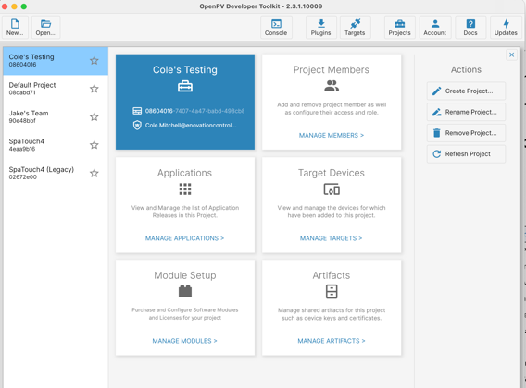
The project view is now organized into sections to allow for improved functionality in each feature area. Note that “Subscriptions” is no longer a supported features as we now support ‘per unit’ Modules Purchases which allows customers to purchase support for Over the Air Updates for a set of devices as well as purchase the required Storyboard and CODESYS licenses as needed for their project.
Project Members – Here you can view and edit project team members as well as assign a role to each member (new). Roles include Administrator, Member, Viewer and Production.
Applications – Here you will find any OTA Applications you have uploaded to “Spark”. You can also search for specific versions.
Devices – Here you will find a list of devices that have been provisioned for OTA in your project. You can now search for the specific devices.
Modules – This new area allows customers to purchase Module Packs for OTA, Storyboard and CODESYS. Once purchased, customers can also add additional quantities to any module over time as needed.
Artifacts – This area contains any keys you have stored in Spark and is functionally the same as the 1.0 Artifacts project tab.

Changes to the Packaging View
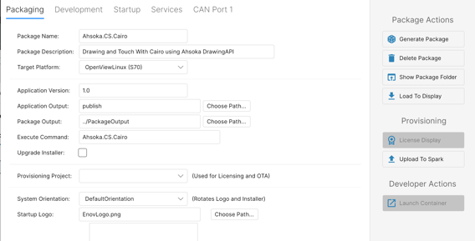
The packaging views have been reorganized to better accommodate new functionality as well as new workflows. When a user first opens a Package Info file, the system will now check to see if they have the latest SDK installed and upgrade as needed.
Package Tab. – Here the user continues to manage their packaging information such as description, hardware type and version. However, this tab now also allows the user to specify the “Provisioning Project” and any necessary Modules needed for the project. Selecting a license for the project will enforce that the device this software is installed on includes the necessary licenses. For development, the “License Display” will acquire any project licenses needed for the display and install them on the target.
Development – Here you will find any settings and properties needed for your choosing UI Development Tool and Software Development Tool. Note that this replaces the CPP, DotNet and Storyboard Tabs in 1.0.
Startup – OpenPV 2.0 now lets the user configure more startup behaviors. Customers can configure the following new features.
- Auto Release System – Allows the system to release systemd either before or after the application starts (eliminates the need to use ReleaseStartup() call.
- Auto Start Services – This feature allows the system to run Ahsoka Service Runtimes as a separate process. This separate process can be started before or after the customer application. The services started by this auto start system are configured on the Services tab.
- After Start Delay – When using Auto Release or Auto Start, this option configures how long after the application is started before executing the Auto features.
- Custom Environment Variables – Customers can now configure a set of environment variables that will be available to the application.

Services – This tab allows the customer to configure which services will be started by the auto start service system as well as change the privacy of any Data Service values that are exposed by the service.
CAN Ports – This tab remains largely the same however we now default the message definitions as the first tab since it is more likely to be used day to day.

New Data Service
OpenPV Introduces a new service intended to help application develpers more easily interact with data producers across the system. This service acts as a central data cache for values around system state, availability of services as well as allowing customers to add their own data / model values without creating tightly coupling between independent and possibly optional system capabilities. Similar to the Shared Variables in PowerVision (Numeric, String, List) this service also provides a system global view of data from across a running system.

- Metadata Info – The DataServiceClient can query for available key values SearchAvailableKeys()” using filters for a given area (Origin) or by the access level of the value (Private, Diagnostic, Public). System generated values always carry an “Origin” which corresponds to the name of the service. Customer generated values may customize the Origin value as needed for their application architecture.
- Getting and Setting Values - Client Applications can add their own values to the DataService using simple GetKeyValues() or request the latest values using SetKeyValue() functions. When setting values, the values are organized by “Origin” (analogous to a namespace) allowing customer applications and system applications to avoid naming collisions.
- Notifications - Client applications can subscribe to sets of values to prevent the need to poll for values allowing more event-driven system architectures. Client applications can also subscribe to changes in the key store allowing them to more easily handle when new services are added at runtime or new values are created after startup.
- Data Visibility - Applications can specify the access level of variables (in the OpenPV Developer Toolkit) for all system values which either allows or disallows access from diagnostics tools such as Cygnus Reach as well as custom external applications.
- Access to Common Data Producers – The system now publishes most common data producers directly to the DataService. This allows more simple applications architectures since values from CAN, IO and Networking are available in a single API vs using the more advanced service API’s needed for each service.

What’s New in OpenPV 2.0
- Customers can now specify a role for Project Members such as alternative administrators as well as member and view only roles.
- Customers can now search and filter or containers (Applications) and devices which are provisioned in Spark.
- Customers can now rename projects.
- Customers can now run the OpenPV Developer Toolkit offline.
- OpenPV is now supported on macOS. – Note that the connection address on a mac is 192.168.9.1 instead of 192.168.7.1
- Customers can now upgrade the Installer UI as part of an Application Package (.opv files)
- Customers can install CODESYS Applications.
- Customers can now manage Royalties for CODESYS and Storyboard by purchasing “Module Packs” in the Project Configuration area.
- Customers can now include BSP Upgrades as part of their Application Package (.opv file)

Changes to API’s
- No longer need to use StartWithExternalServices if using Pre-Configured System Startup (C++ or C#) - NonBreaking
- OpenPV now supports configuring the Wireless Module as an Access Point. Support is via a second Adapter configuration available in the Network Service. Note that the system can only be configured for Client OR Access Point and attempts to enable both capabilities at the same time will lead to an exception. Also note that the current implementation does NOT support WPA3 when in Access Point mode.
Optional BSP Updates
- Added support for starting CODESYS applications using the standard startup system.

